Singapore University of Technology and Design  
Information Systems Technology and Design  
50.008 Database  
  
Online Bookstore Project 2014

Contents

Group Members 1

Key Folders 1

ER Diagram 2

Schema Design 3

Implementing CHECK Constraints in MYSQL 4

Initial Insertion of Test Data 4

SQL Queries 5

Implementation 8

Screenshots of Application 9

## Group Members

1. William Haw (1000043)
2. Cheah Yew Hong, Kenneth (1000124)
3. Lee Ting’en Kevin (1000139)
4. Scott Chiang Chun Wei (1000238)
5. Immanuella Lim Hao Ni (1000342)

## Key Folders

|  |  |
| --- | --- |
| **Path** | **Description** |
| BunsAndNoodle\ | Parent directory |
| BunsAndNoodle\SQL files | Contains the SQL files for the schema, triggers, and insertion of initial data |
| BunsAndNoodle\bns | Contains the application developed using NetBeans IDE 8.0.2 running on Glassfish Server 4.1 and MYSQL 5.6.2 |
| BunsAndNoodle\bns\web | Contains all of the JSP pages which were coded |

Table 1: Key folders

## ER Diagram

Figure 1: ER diagram

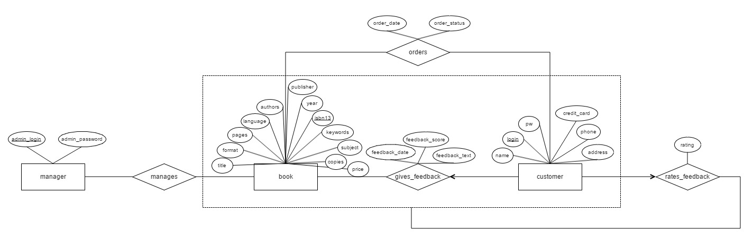

Based on the project requirements, we have designed the ER diagram above.

## Schema Design

We then proceeded to write the SQL statements for the tables based on the ER diagram, adding in additional CHECK constraints where it was applicable.

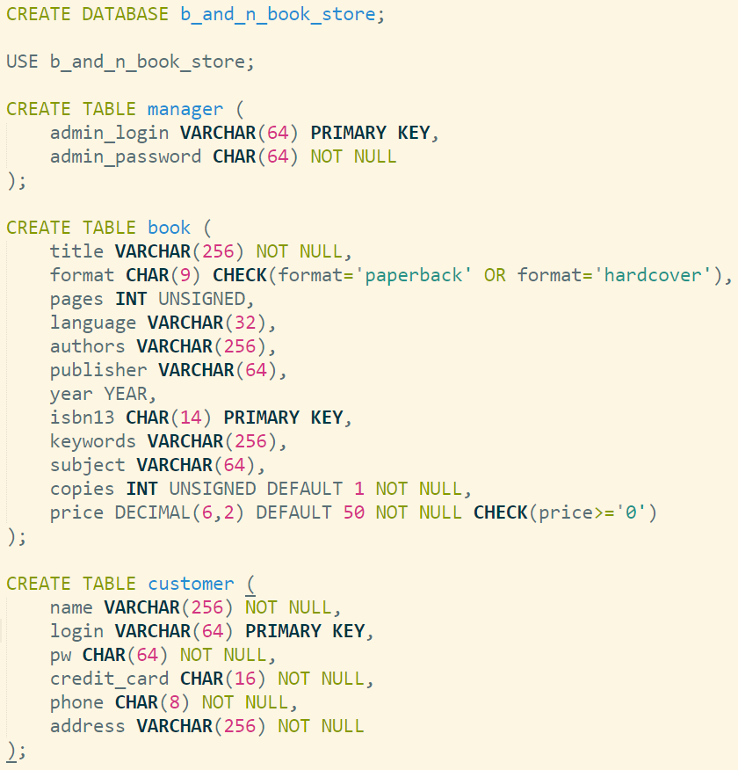  
Figure 2: SQL statements for the manager, book and customer entities

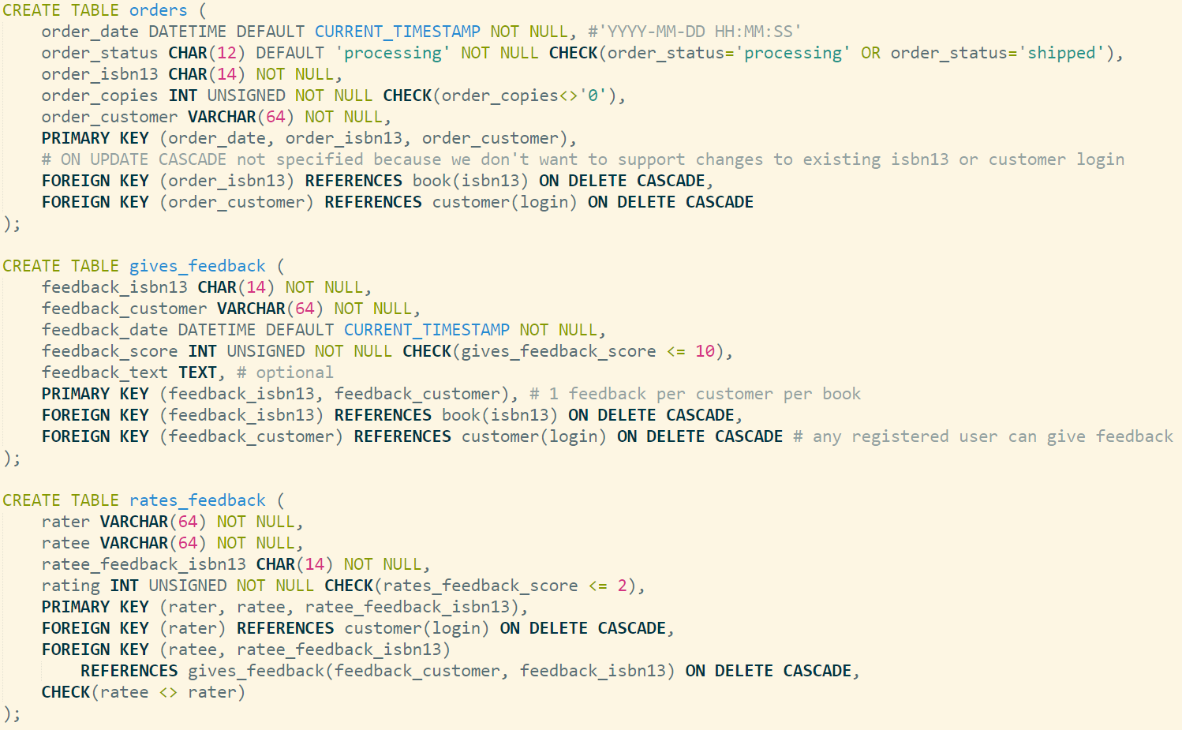  
Figure 3: SQL statements for the order, gives_feedback and rates_feedback relationships

## Implementing CHECK Constraints in MYSQL

Given that CHECK statements are parsed but not actually implemented in MYSQL, we created our own triggers to enforce the various CHECK constraints which we had created. For example, we needed to check that the book format is either ‘paperback’ or ‘hardcover’, or that the feedback score does not exceed 10, or that a customer cannot be rating his or her own feedback on a book etc. By enforcing such rules at the database level, it helped to ensure that the initial insertion of test data into the database conformed to those rules. It also minimized the likelihood of mistakes during application level development.

Here is a sample trigger which ensures the format of the book is either ‘paperback’ or ‘hardcover’ and that the book price cannot be negative.

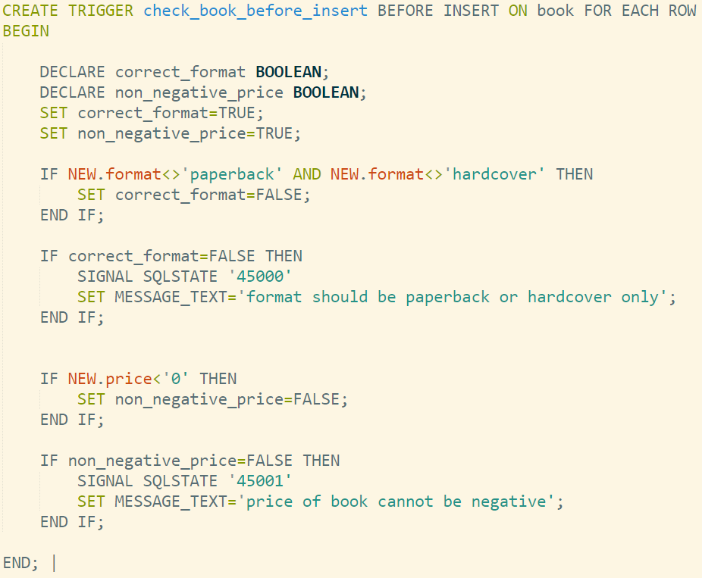  
Figure 4: Sample Trigger

The rest of the triggers are located in BunsAndNoodle\SQL files\2.Triggers.sql

## Initial Insertion of Test Data

As part of the development process, we had to create some dummy data for testing purposes. For example, after inserting the data, we tested out the various SQL queries to make sure they generated the correct output we wanted. Moreover, it allowed application developers to check if the results were being drawn out from the database and displayed on the webpage correctly.

In total, we inserted 100 legitimate books from 10 different subjects, 11 customers, 1 store manager, 3 orders, 10 book feedbacks (some feedbacks were applied to the same book by different customers so that we could calculate the average score) and 10 user ratings on the feedback given.

The SQL insertion statements for the various tables are located in BunsAndNoodle\SQL files\.

## SQL Queries

|  |  |
| --- | --- |
| **System Functionality** | **SQL Statements** |
| User registration | insert into customer (name, login, pw, credit_card, phone, address)  values (fullname, user, pwd, credit_card, phone, address) |
| User login | select * from customer where login = userid and pw = pwd |
| User record – account information | select name, credit_card, phone, address from customer  where customer.login = ? <sql:param value=“${userid}”/> |
| User record – history of orders | select title, order_date, order_copies, order_status from orders inner join book on book.isbn13 = orders.order_isbn13 where order_customer = ? <sql:param value=“${userid}”/> |
| User record – history of feedbacks | select title, feedback_date, feedback_score, feedback_text from gives_feedback inner join book on book.isbn13 = gives_feedback.feedback_isbn13 where feedback_customer = ? <sql:param value=“${userid}”/> |
| User record – history of usefulness ratings on feedbacks | select title, name, feedback_text, feedback_score, rating  from rates_feedback inner join gives_feedback  on (ratee, ratee_feedback_isbn13) = (feedback_customer, feedback_isbn13)  inner join customer on ratee = customer.login  inner join book on ratee_feedback_isbn13 = book.isbn13  where rater = ? <sql:param value=“${userid}”/> |
| User browses books by conjunctive queries, with sorting by year or average score of feedback | select title, format, pages, language, authors, publisher, year, isbn13, subject, copies, price, round(avg(gives_feedback.feedback_score), 2) as avg_score from book left join gives_feedback on book.isbn13 = gives_feedback.feedback_isbn13  where book.title rlike ? <sql:param value=“${param.title}”/>  and book.authors rlike ? <sql:param value=“${param.authors}”/>  and book.publisher rlike ? <sql:param value=“${param.publisher}”/>  and book.subject rlike ? <sql:param value=“${param.subject}”/>  group by book.isbn13  order by avg(gives_feedback.feedback_score) desc  // order by year desc; |
| For a given book, user views book details | select title, format, pages, language, authors, publisher, year, isbn13, subject, copies, price from book  where book.isbn13 = ? <sql:param value="${param.isbn13}"/> |
| For a given book, user views all the feedback and ratings on it (top n) | select feedback_text, feedback_score, feedback_customer, name, feedback_date, avg(ifnull(rating,0)) as avgScore, count(rating) as ratingCount from (select feedback_customer, feedback_date, feedback_score, feedback_text, name, feedback_isbn13 from gives_feedback  inner join customer on customer.login=gives_feedback.feedback_customer  where feedback_isbn13 = ? <sql:param value="${param.isbn13}"/>) as K  left join rates_feedback on rates_feedback.ratee=feedback_customer  and ratee_feedback_isbn13=feedback_isbn13  group by feedback_text, feedback_score, feedback_customer, name, feedback_date  order by avgScore DESC  limit <c:out value="${toView}"/>; |
| For a given book, user enters in his or her feedback | "insert into gives_feedback(feedback_isbn13,feedback_customer,feedback_date,feedback_score,feedback_text) " + values ('" + isbn13 + "','" + user + "','" + currentTime + "','" + score + "','" + feedback + "')"); |
| For a given book, user rates the usefulness of other users’ feedback | "insert into rates_feedback(rater,ratee,ratee_feedback_isbn13,rating) " +  "values ('" + user + "','" + ratee + "','" + isbn13 + "','" + score +"')"); |
| For a given book, user orders x copies of it (insert new order and update the book quantity) | "insert into orders(order_date, order_status, order_isbn13, order_copies, order_customer) " + "values ('" + date + "','" + status + "','" + isbn + "','" + order_copies + "','" + cust_name + "')");  "update book set copies = '" + new_copies + "'where isbn13='" + isbn + "'"); |
| User gets book recommendations after ordering books, sorted by most popular recommendations first | select title, format, pages, language, authors, publisher, year, isbn13, subject, copies, price from book  where isbn13 in (  select order_isbn13 from orders  where order_customer in (  select order_customer from orders  where order_isbn13 = "<%= request.getParameter("isbn13")%>"  having order_customer <> ? <sql:param value="${userid}"/>)  group by order_isbn13  having order_isbn13 <> "<%= request.getParameter("isbn13")%>"  order by count(*) desc);  Note ‘<>’ means ‘Not equals’ |

Table 2: SQL queries for users

|  |  |
| --- | --- |
| **System Functionality** | **SQL Statements** |
| Store manager – login | select * from manager  where admin_login = admin  and admin_password = pwd |
| Store manager – enter new book | "insert into book(title, format, pages, language, authors, publisher, year, isbn13, keywords, subject, copies, price) " +  "values ('" + title + "','" + book_format + "','" + Integer.parseInt(pages) + "','"  + language + "','" + authors + "','" + publisher + "','"  + year + "','" + isbn13 + "','" + keywords + "','"  + subject + "','" + Integer.parseInt(copies) + "','" + Float.parseFloat(price) + "')" |
| Store manager – update book copies | "select copies from book where isbn13 = '" + isbn13 + "'" current_copies = rs.getInt("copies");  total_copies = current_copies + Integer.parseInt(number_new_copies);  "update book set copies = '" + total_copies + "'where isbn13='" + isbn13 + "'" |
| Store manager – view top m popular books per month | select title, sum(order_copies) as summed_copies, order_date, order_isbn13  from orders inner join book on order_isbn13 = book.isbn13  where month(order_date) rlike ? <sql:param value="${param.month}"/>  and year(order_date) rlike ? <sql:param value="${param.year}"/>  group by order_isbn13  order by summed_copies desc  limit <c:out value="${param.number_results}"/> |
| Store manager – view top m popular authors | select authors, title, sum(order_copies) as summed_copies, order_date, order_isbn13 from orders inner join book on order_isbn13 = book.isbn13  where month(order_date) rlike ? <sql:param value="${param.month}"/>  and year(order_date) rlike ? <sql:param value="${param.year}"/>  group by order_isbn13  order by summed_copies desc  limit <c:out value="${param.number_results}"/> |
| Store manager – view top m popular publishers | select publisher, title, sum(order_copies) as summed_copies, order_date, order_isbn13 from orders inner join book on order_isbn13 = book.isbn13  where month(order_date) rlike ? <sql:param value="${param.month}"/>  and year(order_date) rlike ? <sql:param value="${param.year}"/>  group by order_isbn13  order by summed_copies desc  limit <c:out value="${param.number_results}"/> |

Table 3: SQL queries for store manager

## Implementation

We developed the application using NetBeans IDE 8.0.2. The backend server was running on Glassfish Server 4.1 which communicated with our MYSQL 5.6.2 database.

Here is a high level schematic of our various JSP pages and their key functions.

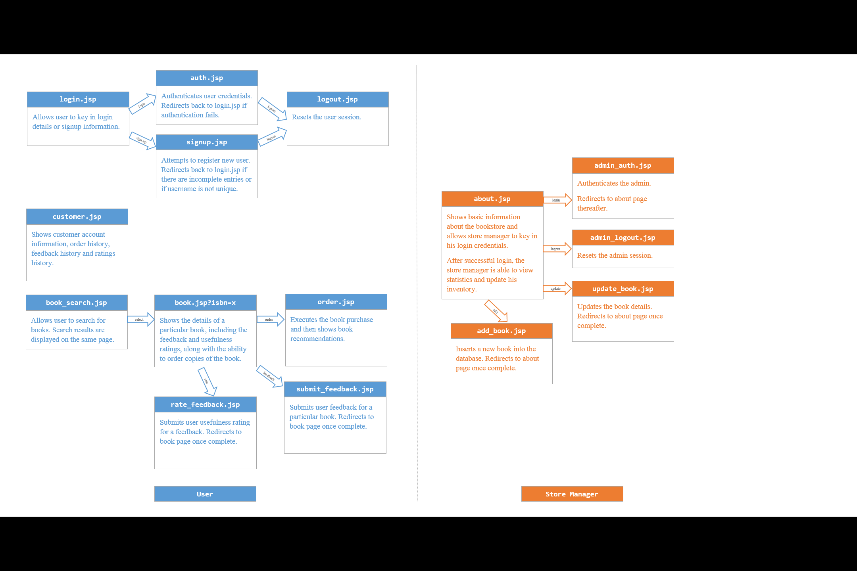  
Figure 5: Schematic of JSP pages

## Screenshots of Application

Here are some screenshots of our web application.

Figure 6: Login and sign-up page

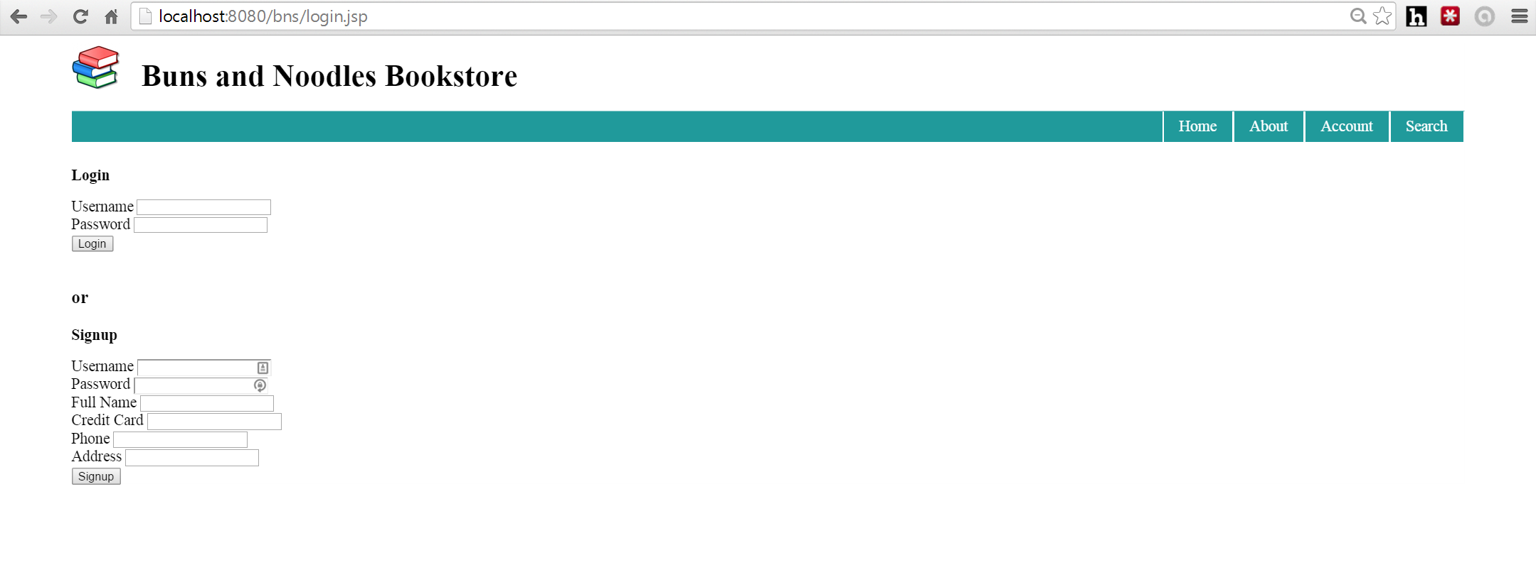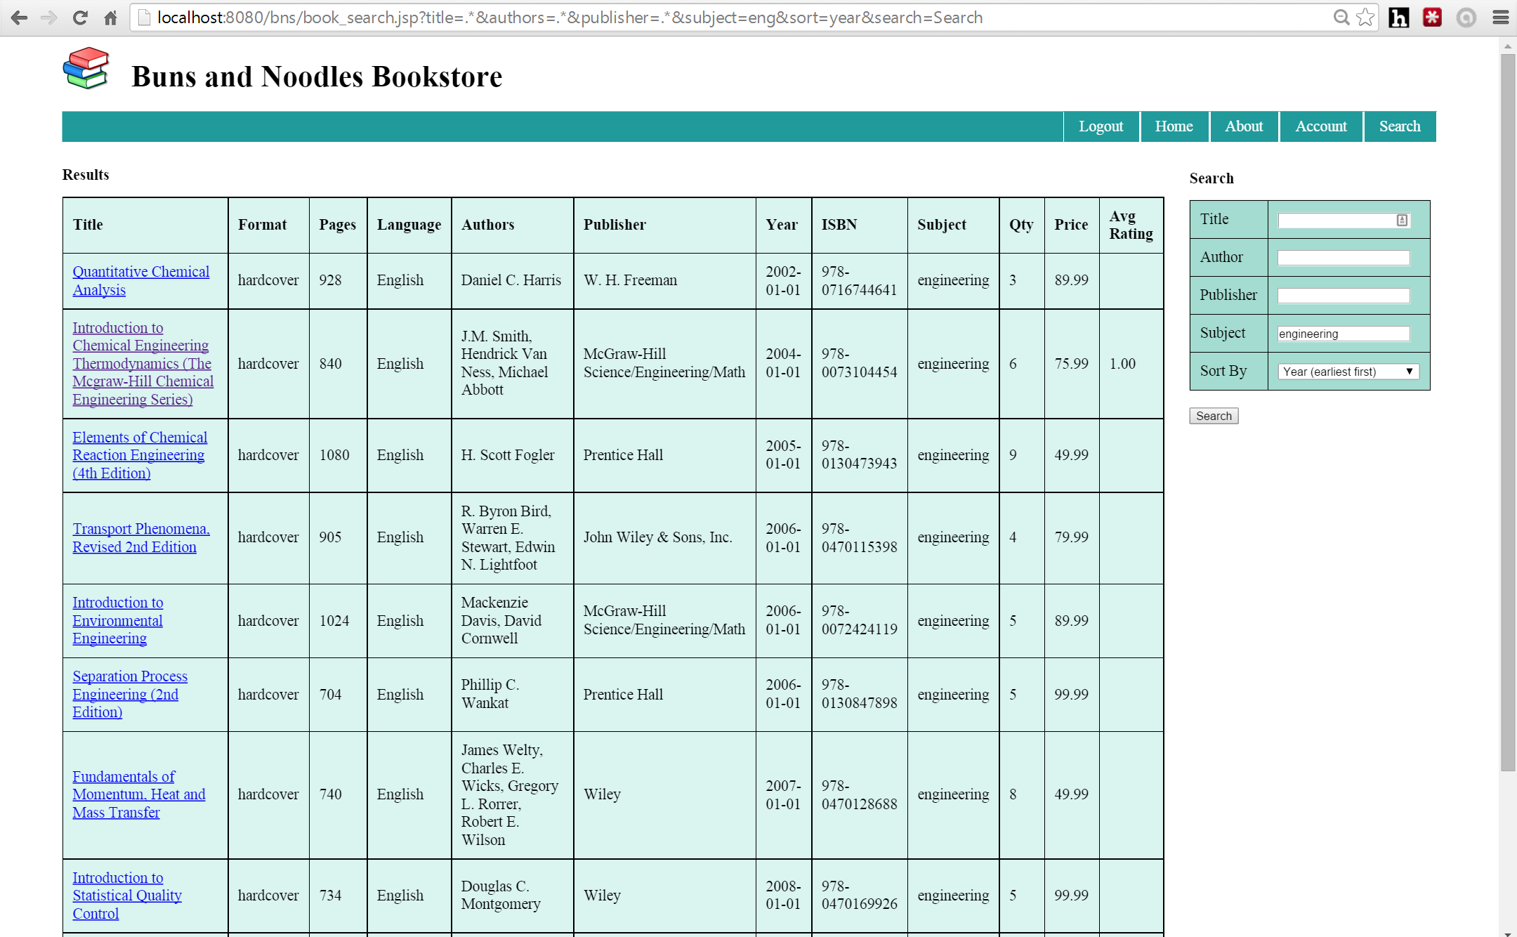

Figure 7: Book search page with hyperlinks to individual book pages

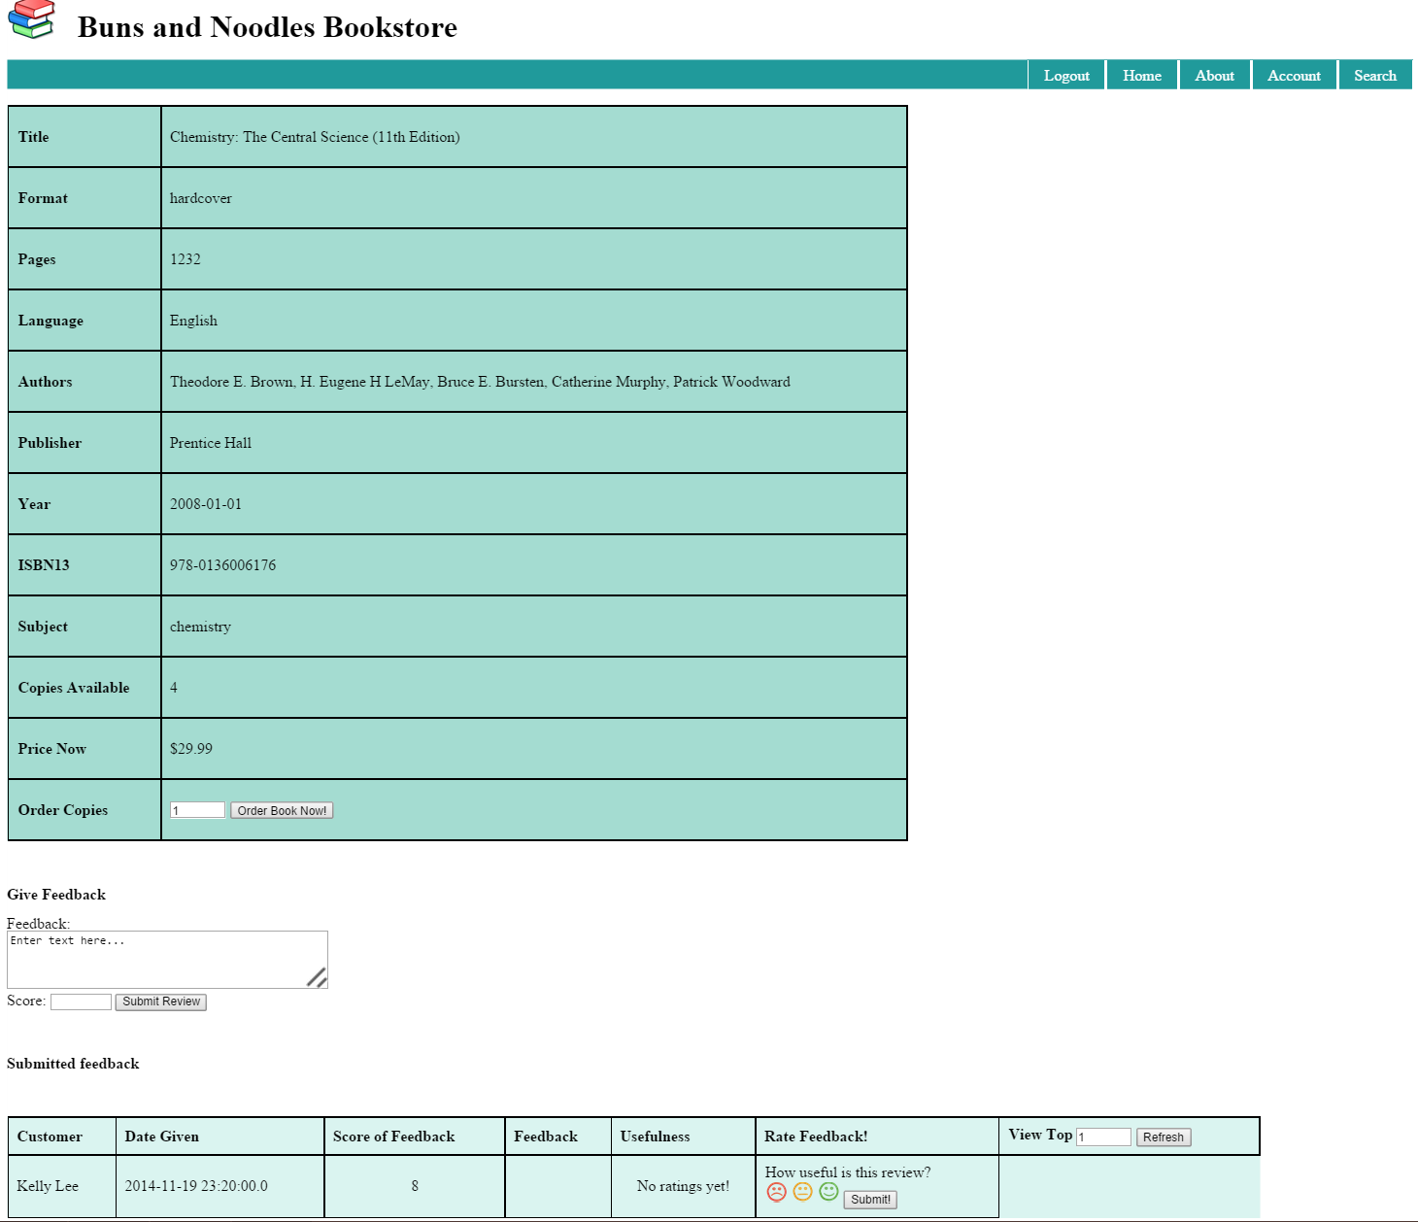

Figure 8: Individual book page

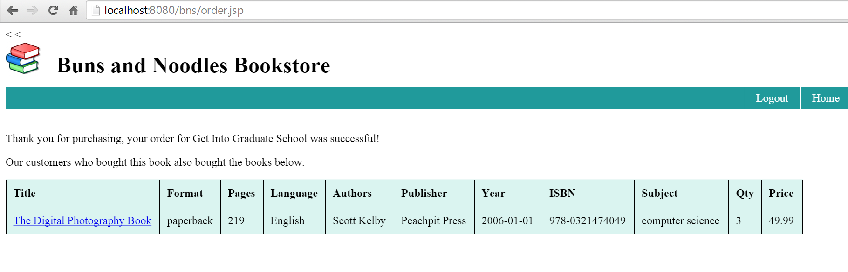

Figure 9: Recommendations after purchase

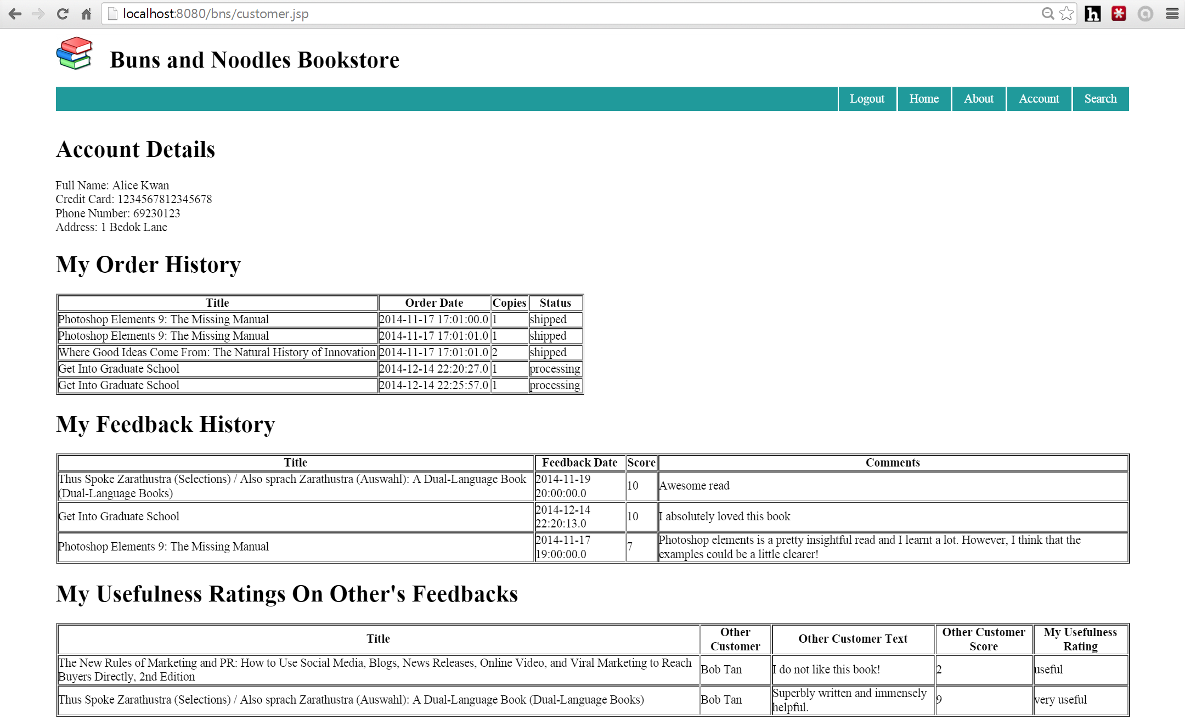

Figure 10: Customer account page

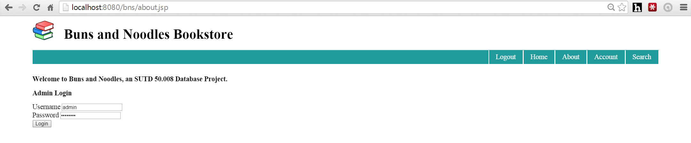

Figure 11: Store manager login

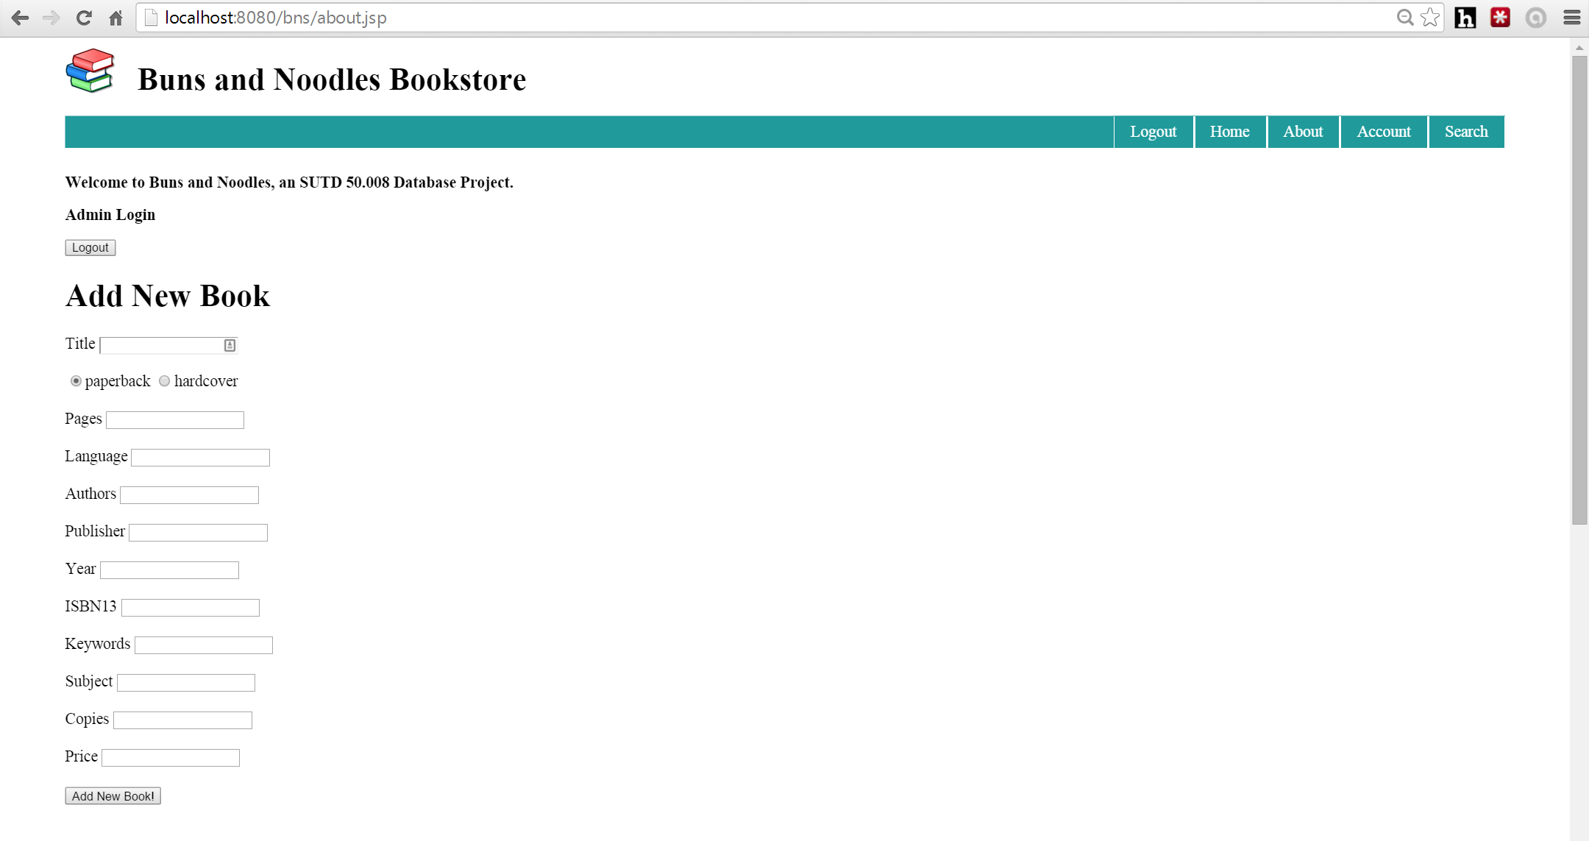

Figure 12: Store manager page (1)

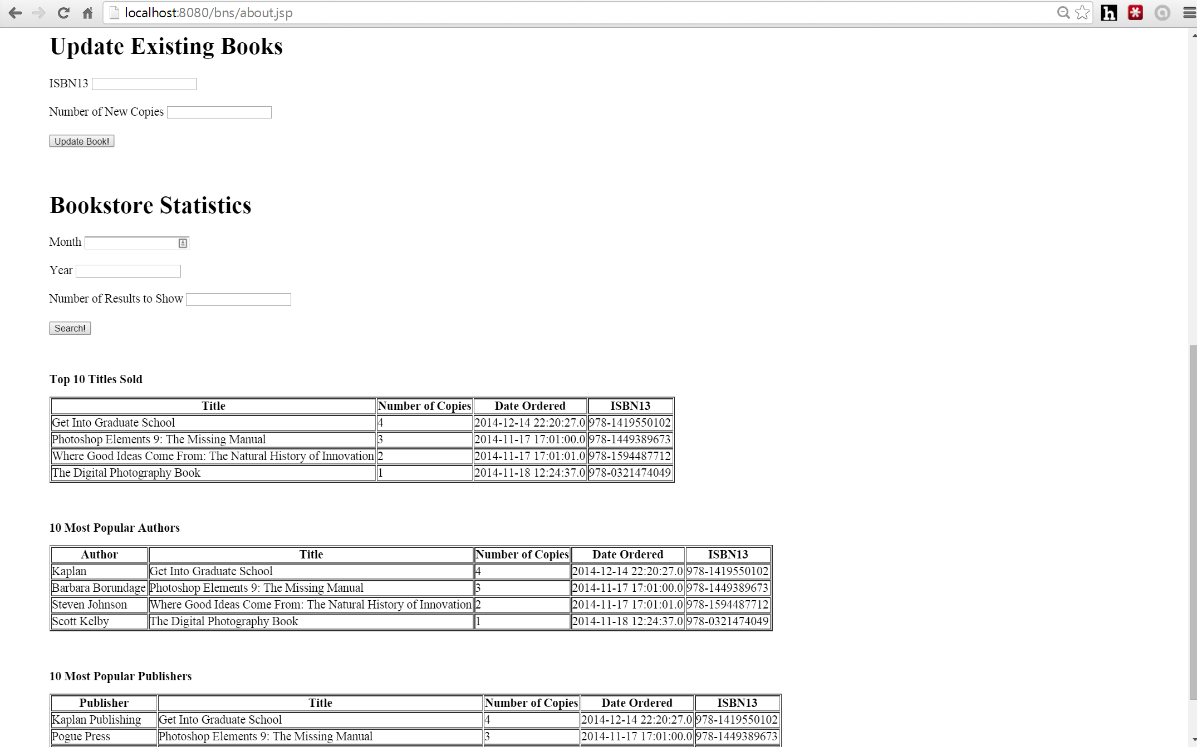

Figure 13: Store manager page (2)